Steven Thaw

sjthaw@me.com

Abstract

A Java program which simulates three traffic intersections. Each stoplight runs on independent threads, which also update the position and speed of the vehicles in that intersection.

CMSC 335 Object Oriented and concurrent programming

Project 3

**UML Class Diagram**

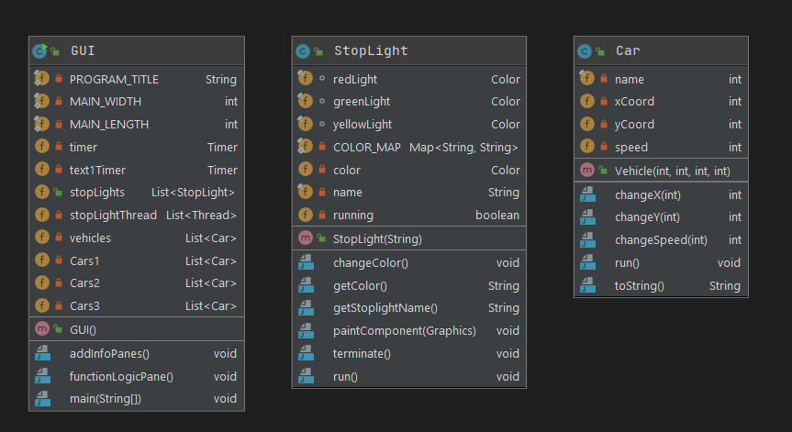

**Setup and Installation Guide**

Unpack the folder into a directory of your choice. Open the console or command prompt depending on your Operating system and navigate to the directory where the files were placed. Type “javac GUI.java” in the console to compile the Java code, and then type “java GUI” to run the program. Once in the program, press one of three buttons to add cars to the corresponding intersection. When the light turns green, the car’s speed and position will update and print to the text box.

**Lessons Learned**

This project was extremely difficult for the author. It was lightyears ahead of everything the author had completed in any UMGC programming course to date. The author was ultimately unable to get the array list of vehicles for each intersection to update when the stoplight turned green. The author learned how to write a color map to provide a string to look up the color of the stoplight, and also learned the proper way to write a loop involving objects, as well as how to create a swing timer. In the end, it was very frustrating not being able to get the green light to update the array list and print the updated values to the text box.

**Test Plan**

|  |  |  |  |
| --- | --- | --- | --- |
| **Test Case** | **Input** | **Expected Output** | **Pass/Fail** |
| 1 | Add Vehicle to Intersection 1 | Car:1 X Position:0. Y Position:0 Speed:0 in text box 1 | Pass |
| 2 | Add Vehicle to Intersection 1 | Car:2 X Position:0. Y Position:0 Speed:0 in text box 1 | Pass |
| 3 | Add Vehicle to Intersection 2 | Car:1 X Position:0. Y Position:0 Speed:0 in text box 2 | Pass |
| 4 | Add Vehicle to Intersection 2 | Car:2 X Position:0. Y Position:0 Speed:0 in text box 2 | Pass |
| 5 | Add Vehicle to Intersection 3 | Car:1 X Position:0. Y Position:0 Speed:0 in text box 3 | Pass |
| 6 | Add Vehicle to Intersection 3 | Car:2 X Position:0. Y Position:0 Speed:0 in text box 3 | Pass |
| 7 | Close The Program | Process Finished with Exit Code (0) | Pass |
| 8 | Text Box 1 Updates on Green Light | Text Box 1 Updates when Light is Green | Fail |
| 9 | Text Box 2 Updates on Green Light | Text Box 2 Updates when Light is Green | Fail |
| 10 | Text Box 3 Updates on Green Light | Text Box 3 Updates when Light is Green | Fail |

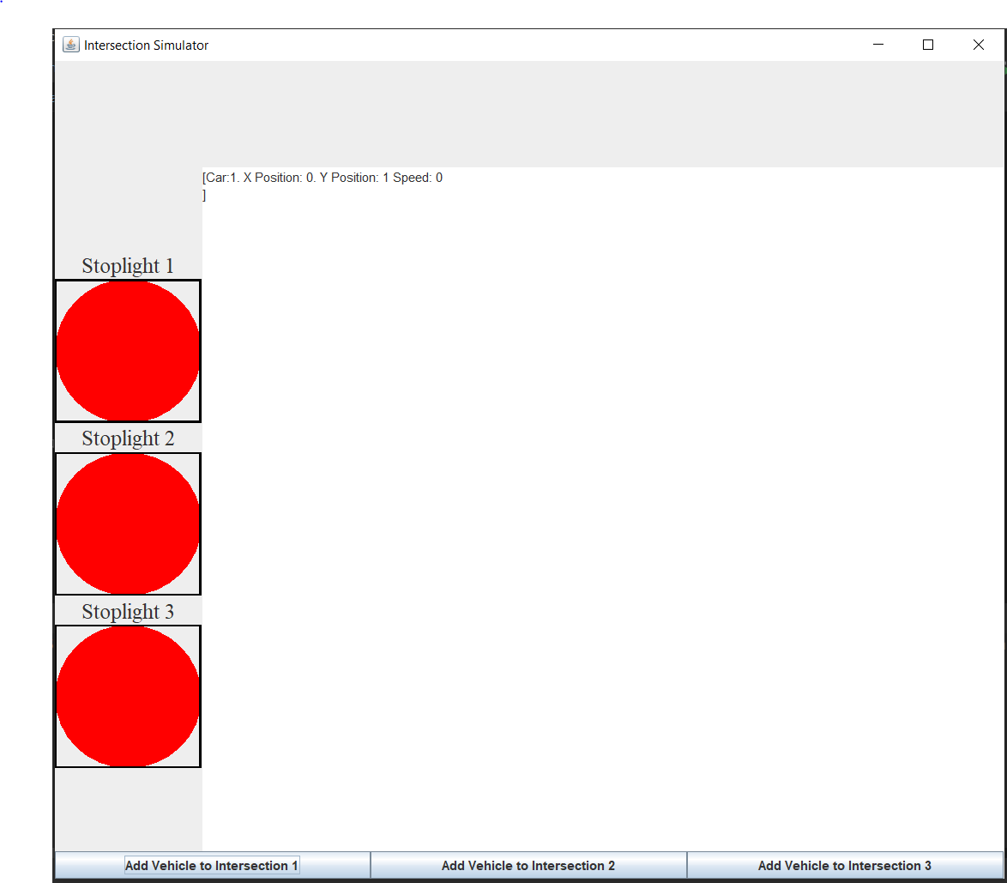

Figure Test Case 1

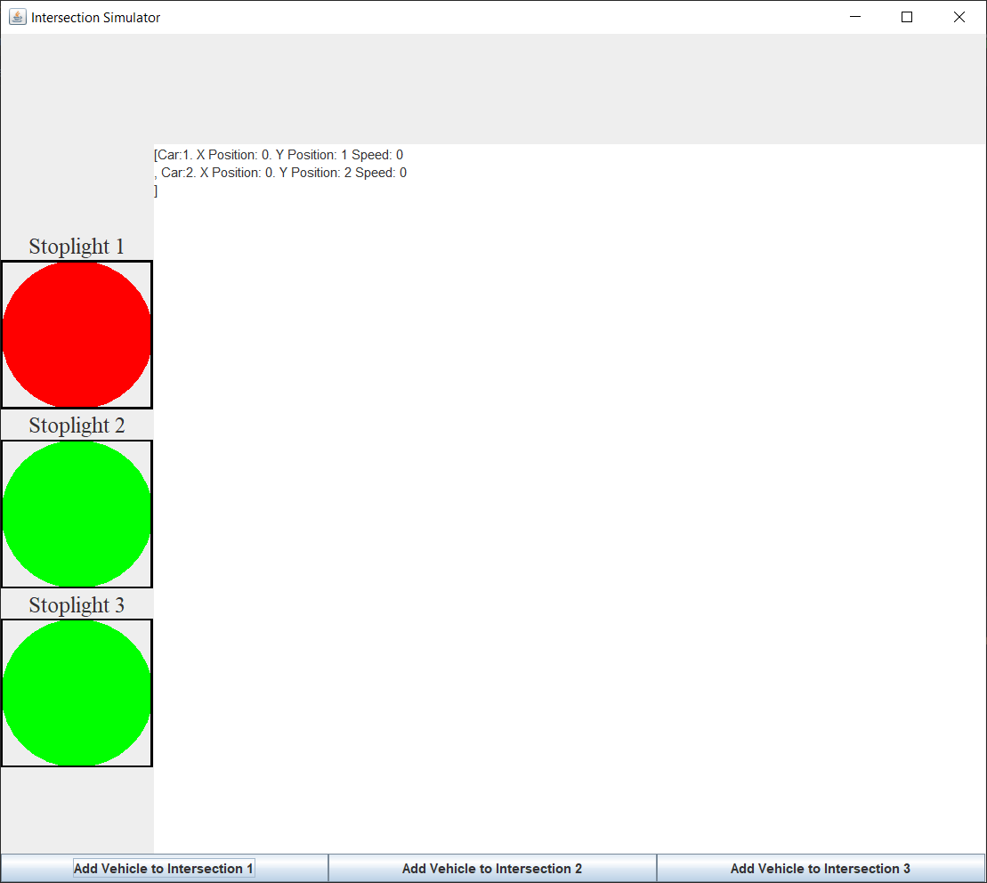

Figure Test Case 2

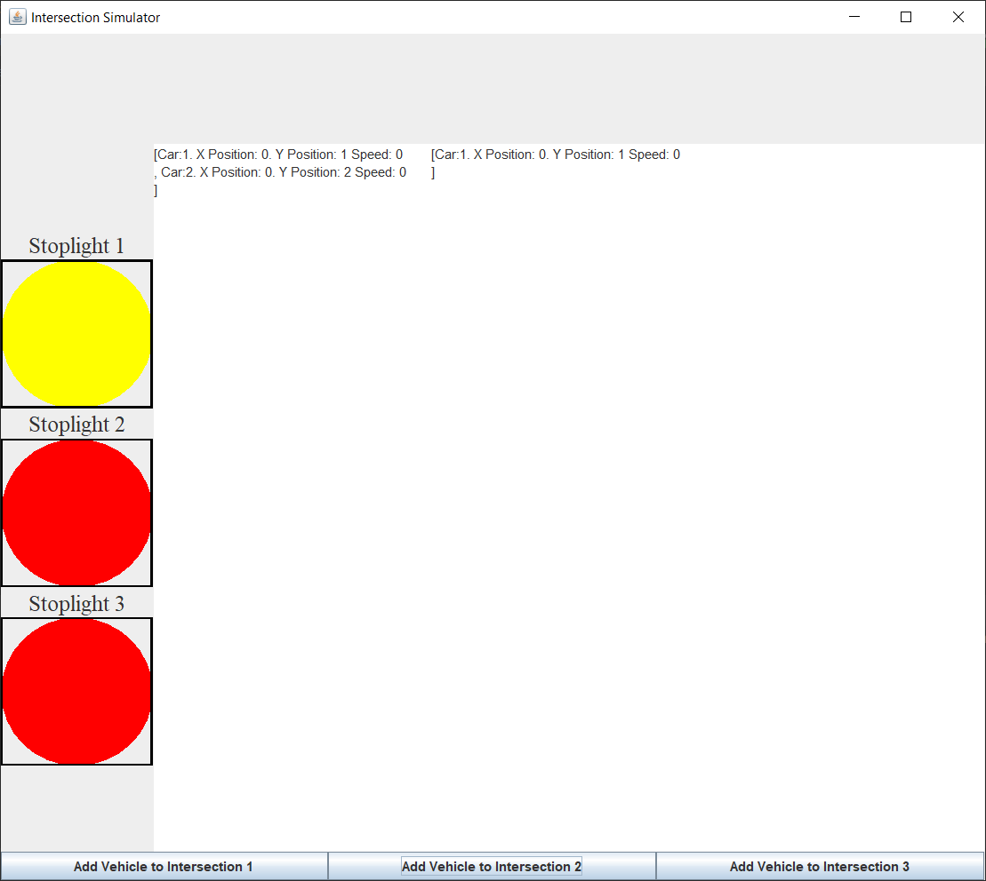

Figure Test Case 3

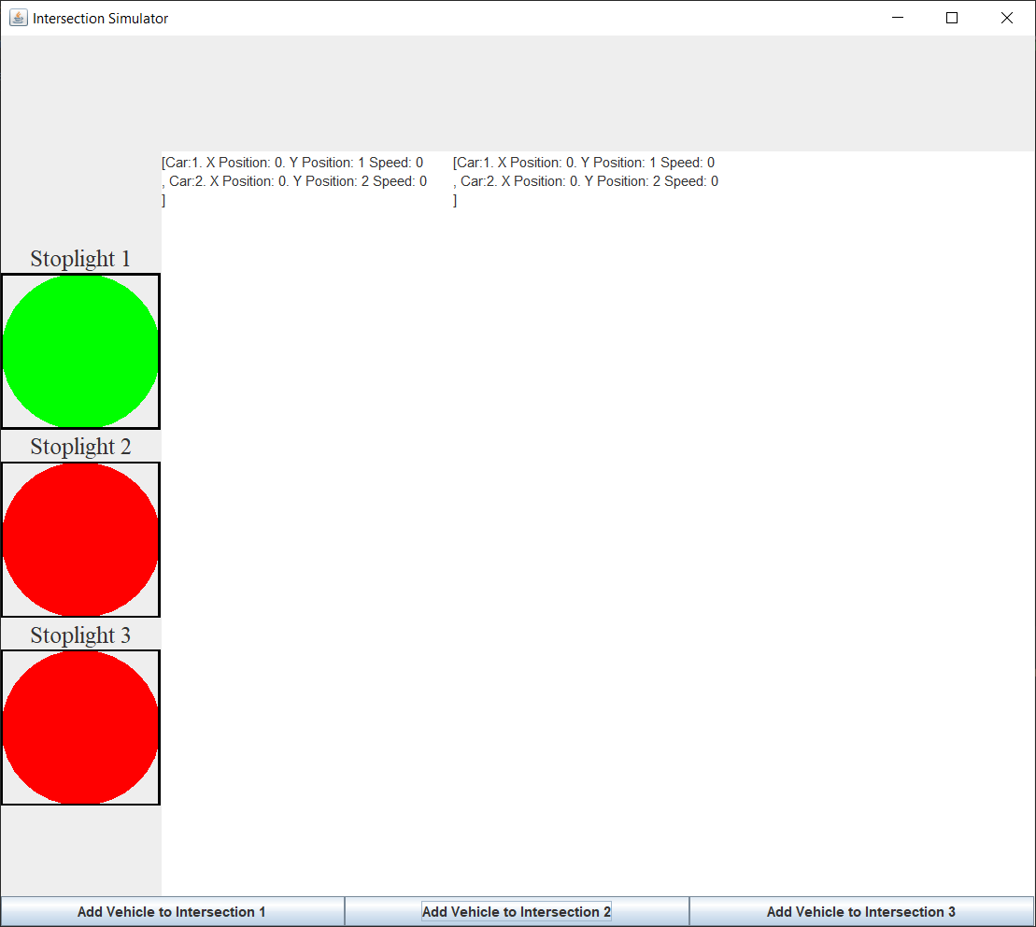

Figure Test Case 4

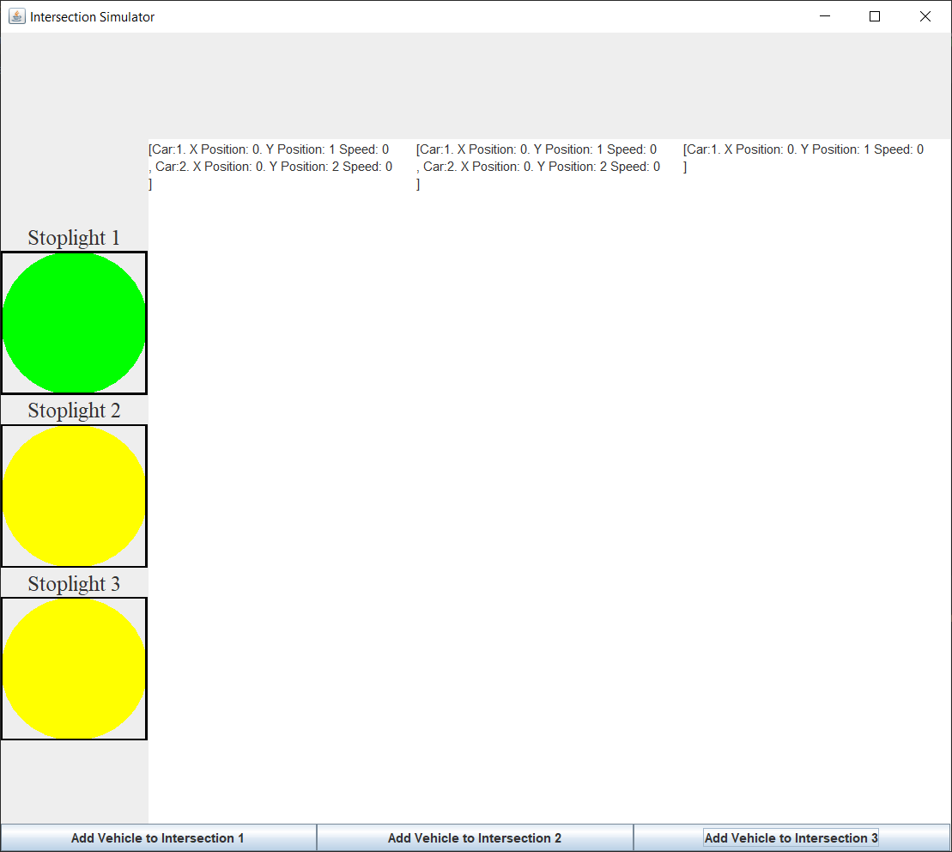

Figure Test Case 5

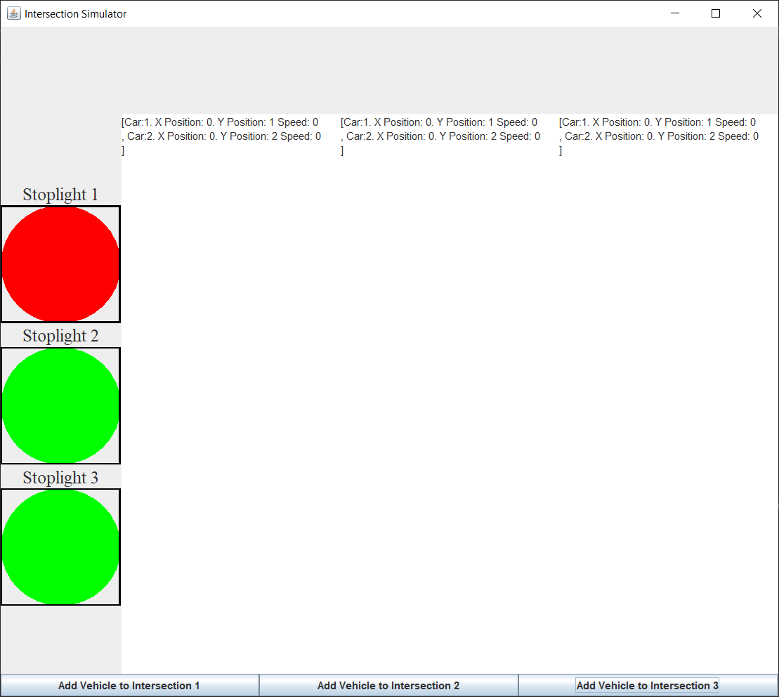

Figure Test Case 6

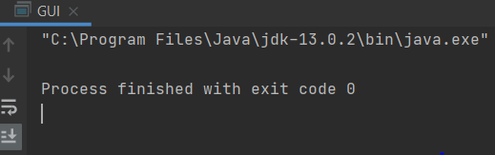

Figure Test Case 7

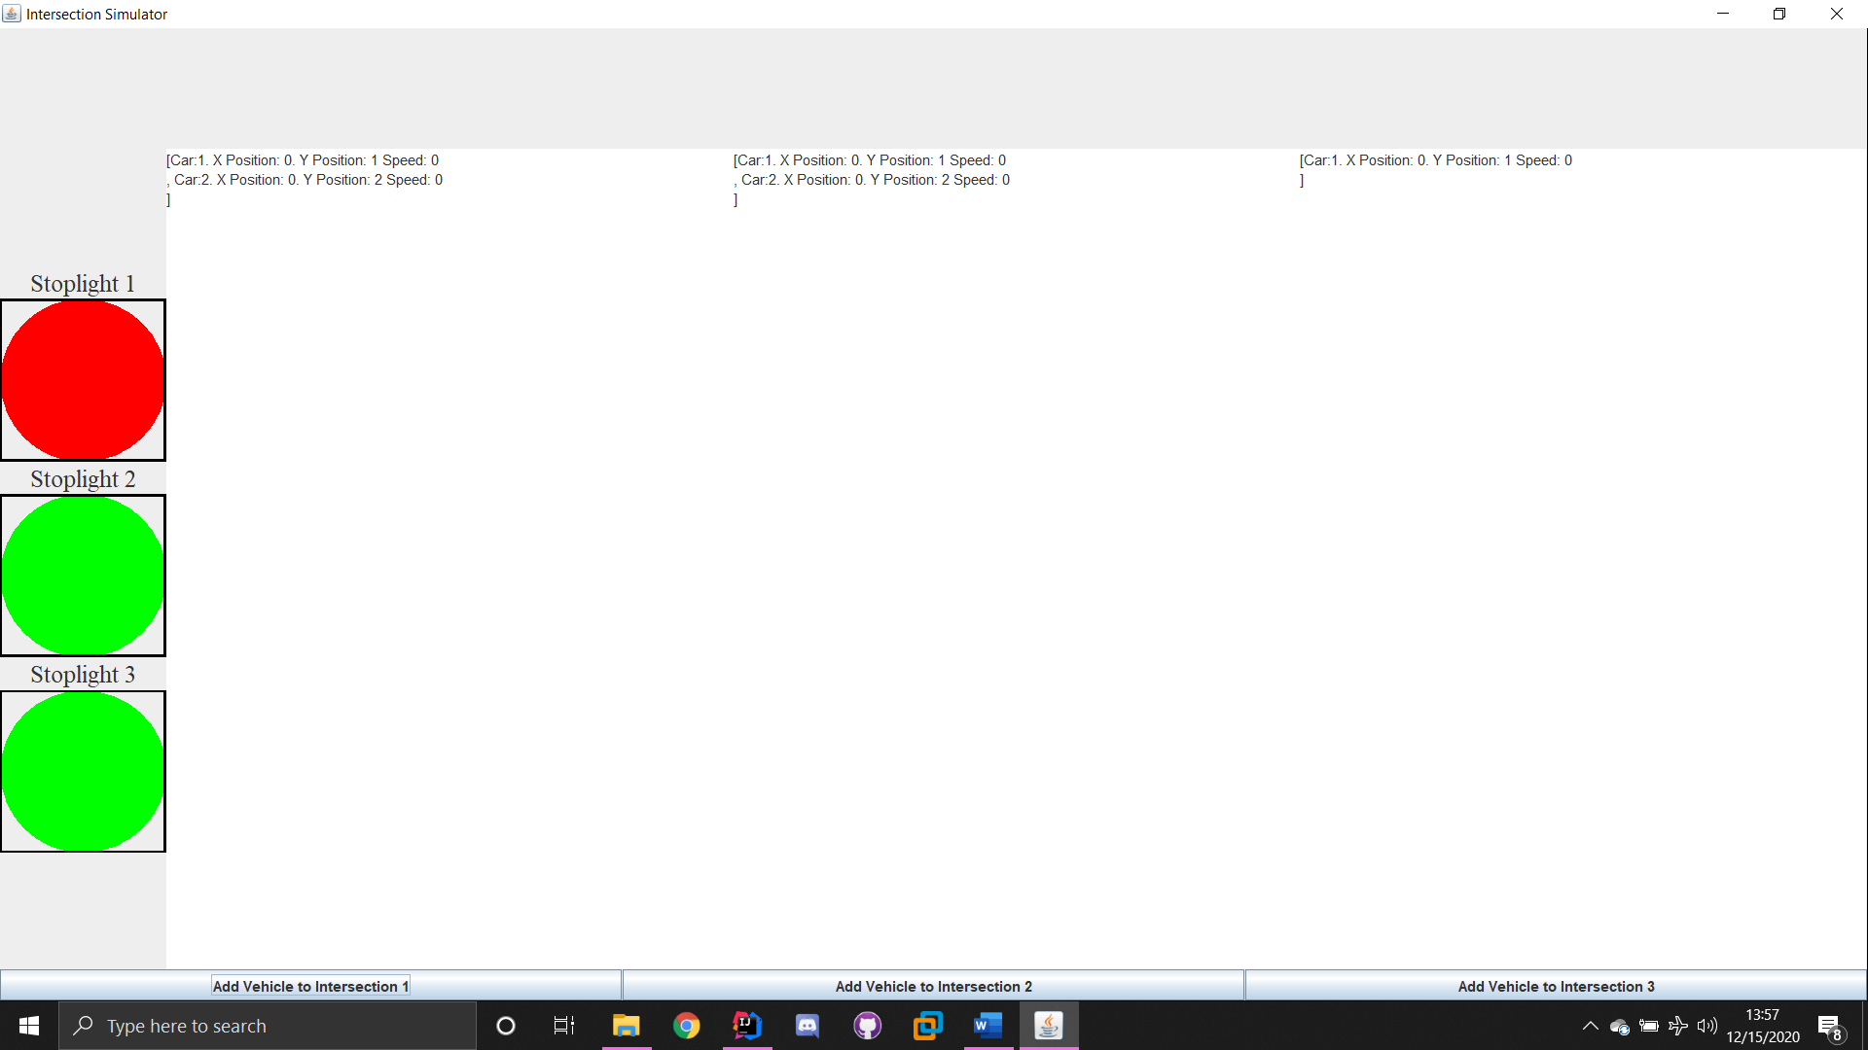

Figure Test Case 8



Figure Test Case 9



Figure Test Case 10